***Solution Section* 1.2 – Region between Curves**

***Exercise***

Find the area of the region bounded by the graphs of  and 

***Solution***







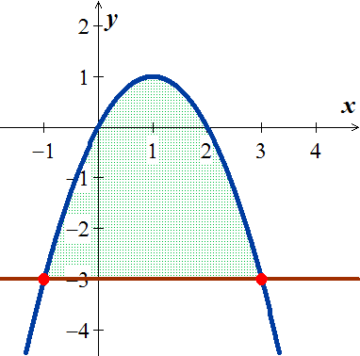









***Exercise***

Find the area of the region bounded by the graphs of  and 

***Solution***

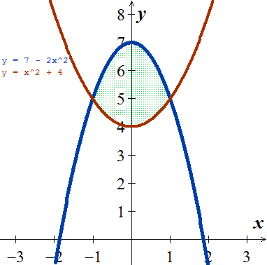















***Exercise***

Find the area of the region bounded by the graphs of  and 

***Solution***

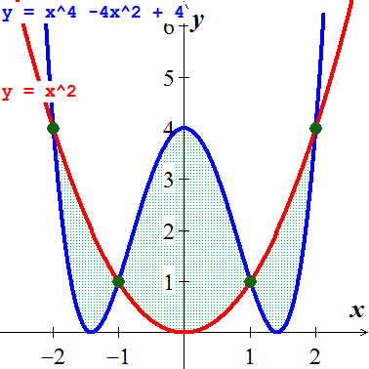



















***Exercise***

Find the area of the region bounded by the graphs of 

***Solution***

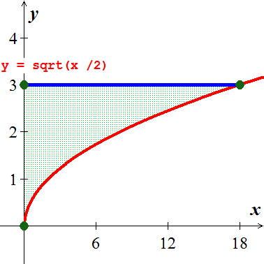









***Exercise***

Find the area of the region bounded by the graphs of 

***Solution***

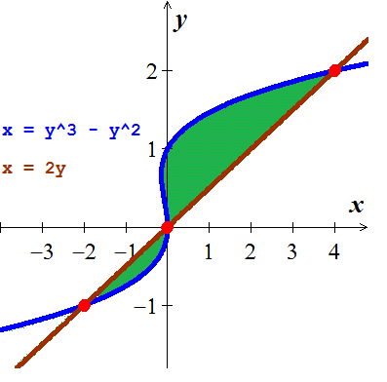



















***Exercise***

Find the area of the region bounded by the graphs of 

***Solution***

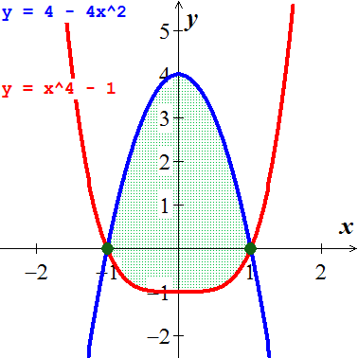





















***Exercise***

Find the area of the region bounded by the graphs of 

***Solution***









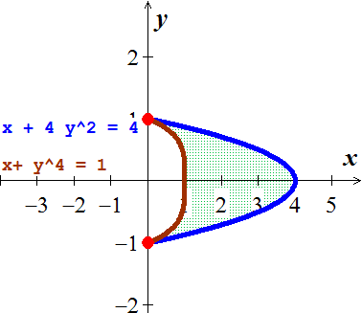













***Exercise***

Find the area of the region bounded by the graphs of 

***Solution***



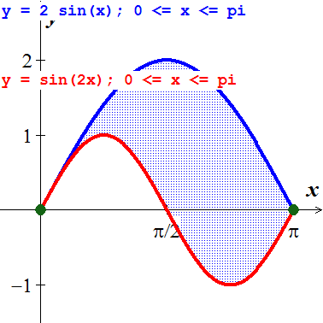















***Exercise***

Find the area of the region bounded by the graphs of 

***Solution***



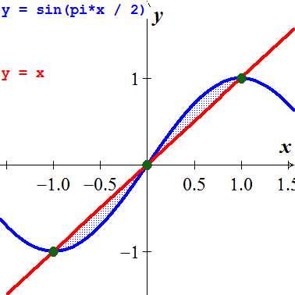















***Exercise***

Find the area of the region bounded by the graphs of  and  for 

***Solution***

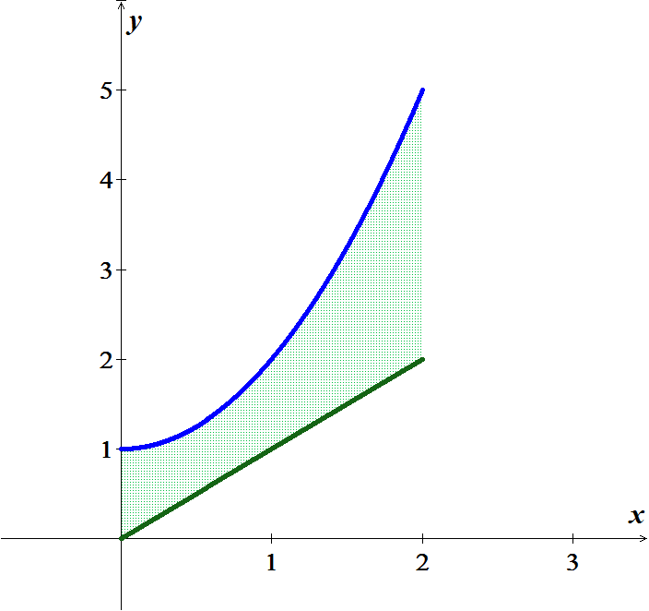









***Exercise***

Find the area of the region bounded by the graphs of  and 

***Solution***



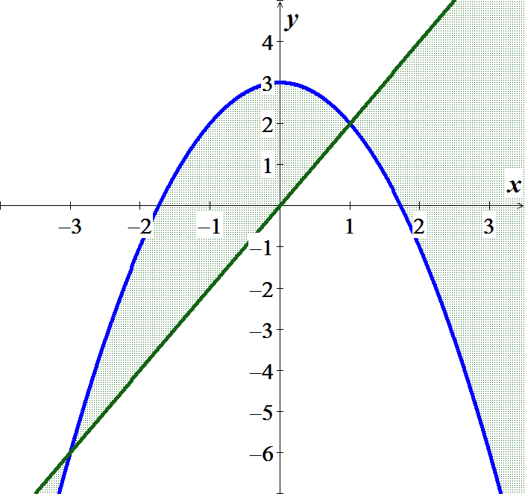













/***Exercise***

Find the area of the region bounded by the graphs of  and *x*-axis

***Solution***

The intersection points: 













***Exercise***

Find the area between the curves 

***Solution***



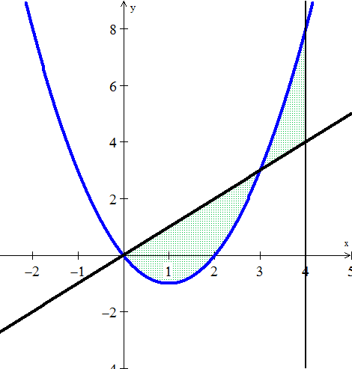













***Exercise***

Find the area of the region bounded by the graphs of  and  on [0, 4].

***Solution***

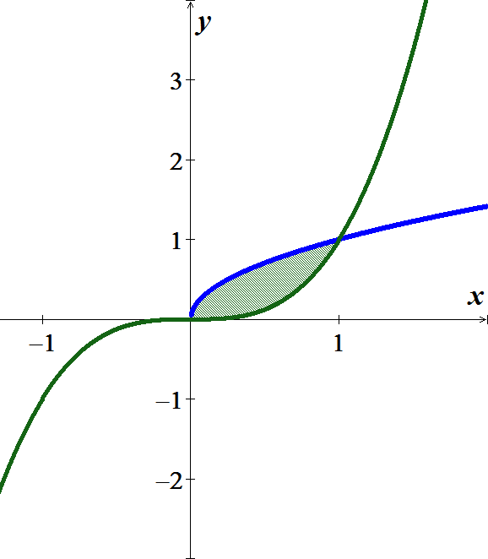



















***Exercise***

Find the area between the curves 

***Solution***

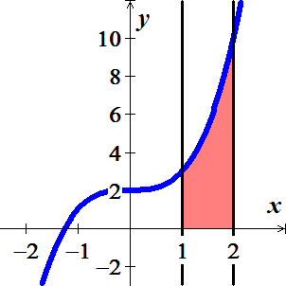









***Exercise***

Find the area between the curves 

***Solution***





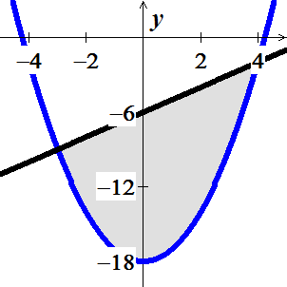













***Exercise***

Find the area between the curves 

***Solution***



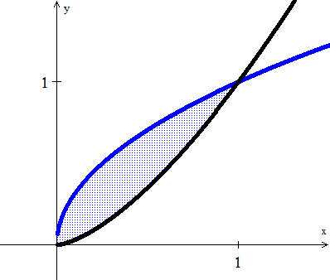













***Exercise***

Find the area of the region bounded by the graphs of  and 

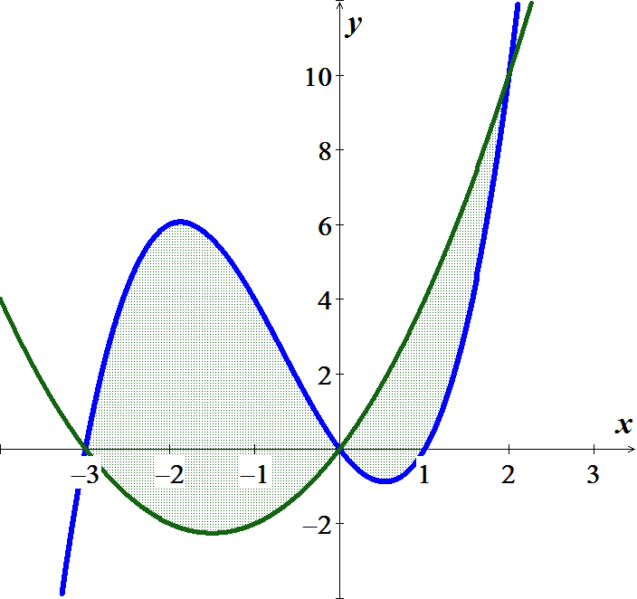***Solution***





















***Exercise***

Find the area of the region bounded by the graphs of 

***Solution***



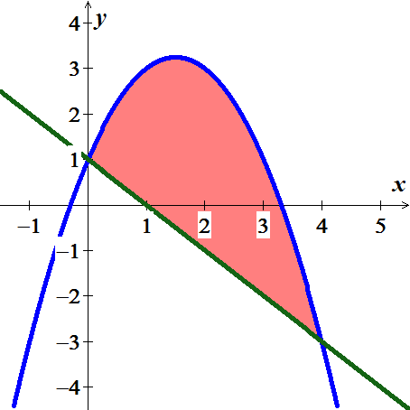













***Exercise***

Find the area of the region bounded by the graphs of 

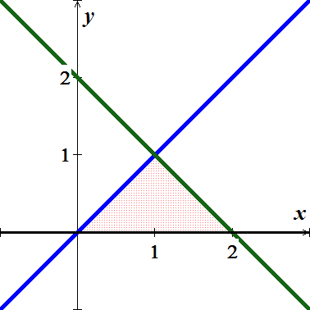***Solution***













***Exercise***

Find the area of the region bounded by the graphs of 

***Solution***

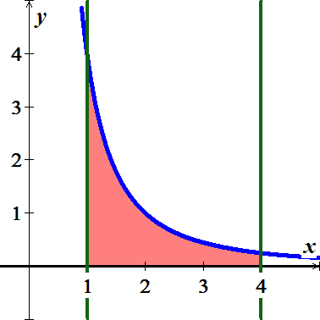







***Exercise***

Find the area of the region bounded by the graphs of 

***Solution***



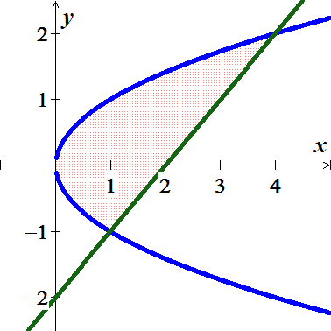











***Exercise***

Find the area of the region bounded by the graphs of 

***Solution***

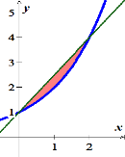







***Exercise***

Find the area of the region bounded by the graphs of 

***Solution***



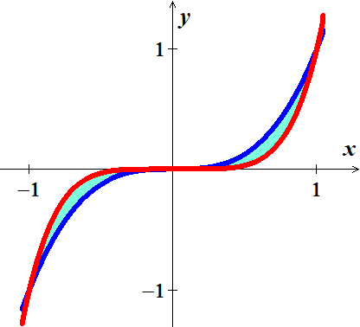



















***Exercise***

Find the area of the region bounded by the graphs of



***Solution***

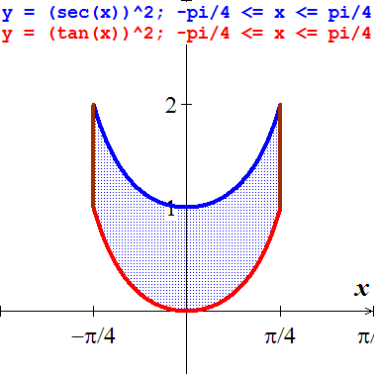











***Exercise***

Find the area bounded by , , , 

***Solution***



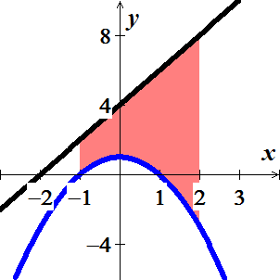 













***Exercise***

Find the area of the region bounded by the graphs of 

***Solution***







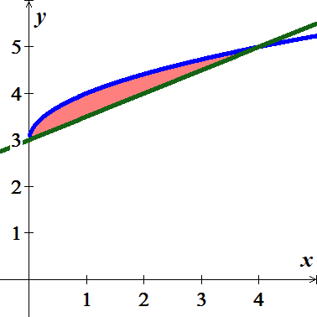









***Exercise***

Find the area of the region bounded by the graphs of 

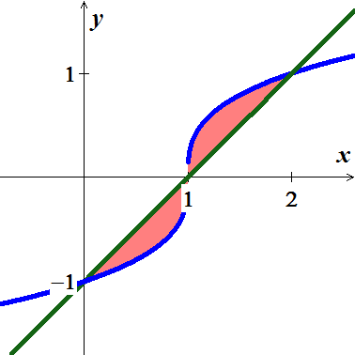***Solution***

















***Exercise***

Find the area of the region bounded by the graphs of 

***Solution***







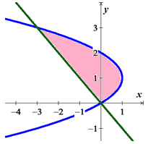









***Exercise***

Find the area of the region bounded by the graphs of 

***Solution***

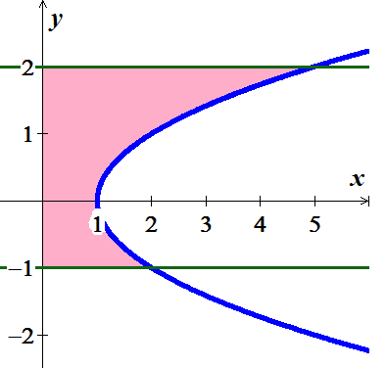







***Exercise***

Find the area of the region bounded by the graphs of 

***Solution***

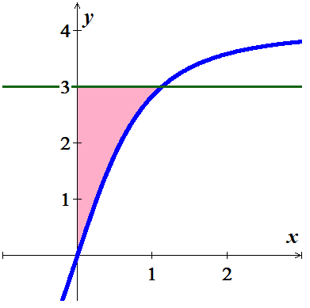







***Exercise***

Find the area of the region bounded by the graphs of 

***Solution***

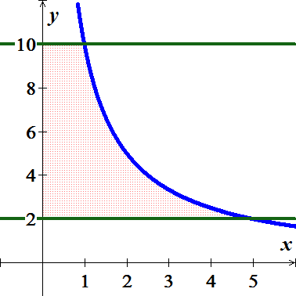









***Exercise***

Find the area of the region bounded by the graphs of 

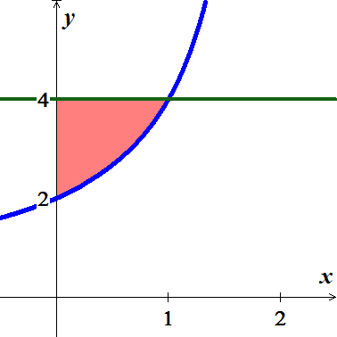***Solution***







 





***Exercise***

Find the area of the region bounded by the graphs of 

***Solution***

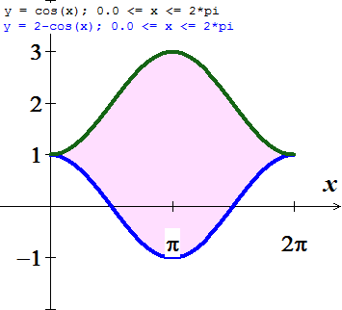







***Exercise***

Find the area of the region bounded by the graphs of 

***Solution***

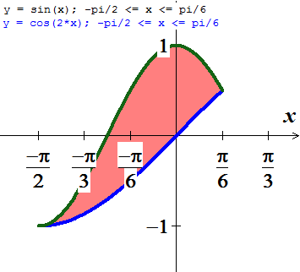







***Exercise***

Find the area of the region bounded by the graphs of 

***Solution***

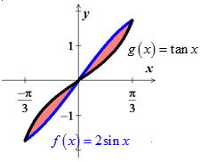







***Exercise***

Find the area of the region bounded by the graphs of



***Solution***

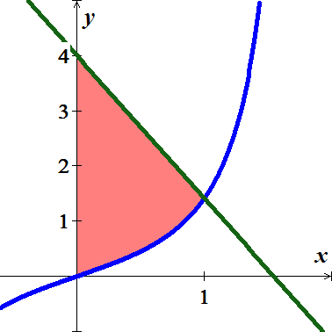



  
 

***Exercise***

Find the area of the region bounded by the graphs of 

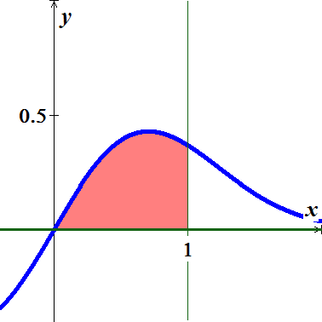***Solution***











***Exercise***

Find the area of the region between  *and* 

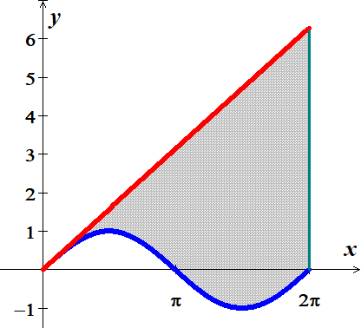***Solution***









***Exercise***

Find the area of the region bounded by ,  *and* 

***Solution***

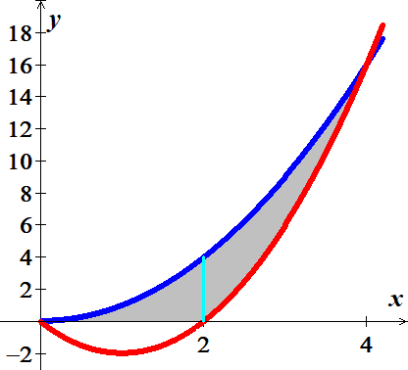















***Exercise***

Find the area of the region bounded by the curves and line 

***Solution***

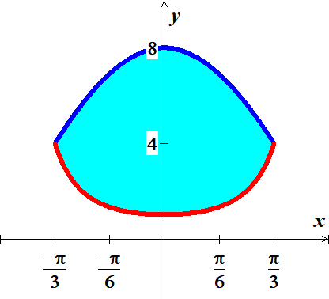







***Exercise***

Find the area of the region bounded by the curves and line 

***Solution***

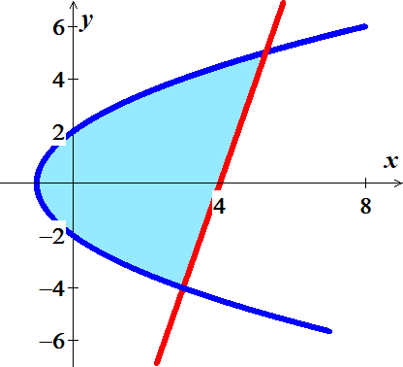





















***Exercise***

Find the area of the region bounded by the curves and line 

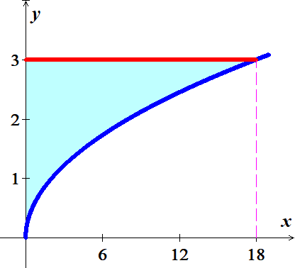***Solution***







***Exercise***

Find the area of the region bounded by the curves: 

***Solution***



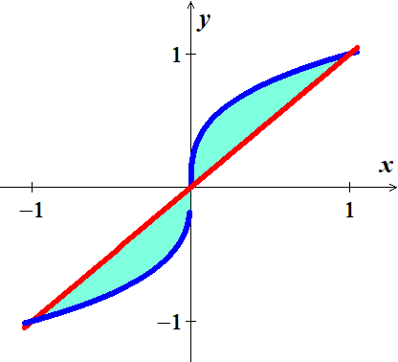













***Exercise***

Find the area of the region in the first quadrant bounded by  *and* 

***Solution***





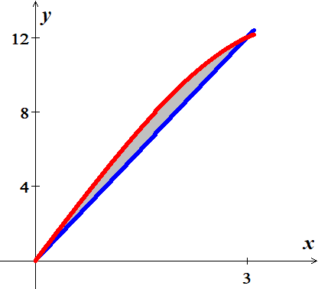













***Exercise***

Find the area of the region in the first quadrant bounded by the curve 

***Solution***

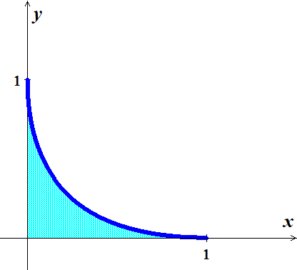















***Exercise***

Find the area of the region in the first quadrant bounded by  and 

***Solution***

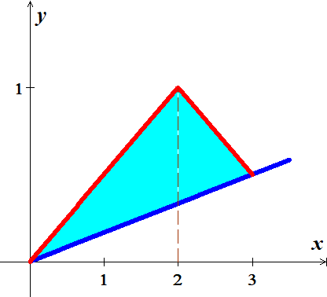















***Exercise***

Find the area of the region in the first quadrant bounded by  and  where  and 

***Solution***

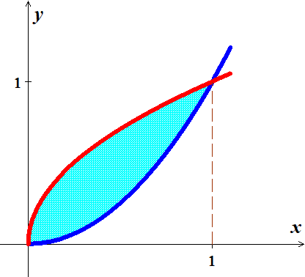











For 



For 



***Exercise***

Consider the functions  and , where . Find , the area of the region between the curves.

***Solution***

















***Exercise***

Find the area between the curves  and  from  to 

***Solution***



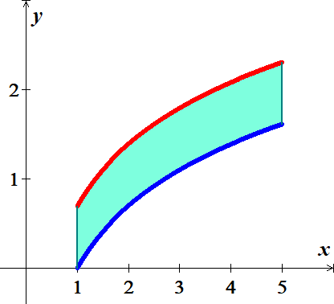 













***Exercise***

Find the total area of the region enclosed by the curve  and lines  and 

***Solution***

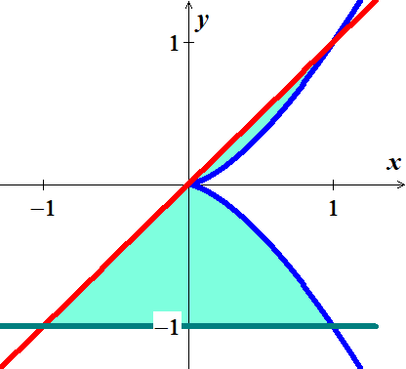











***Exercise***

Find the area of the “triangular region in the first quadrant bounded on the left by the *y-axis* and on the right by the curves 

***Solution***





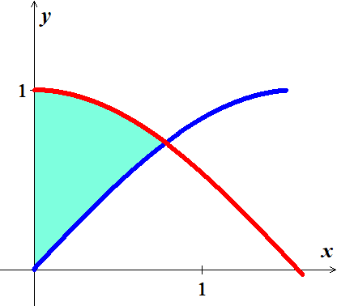







***Exercise***

Find the area of the “triangular region in the first quadrant bounded above by the curve , below by the curve , and on the right by the line 

***Solution***



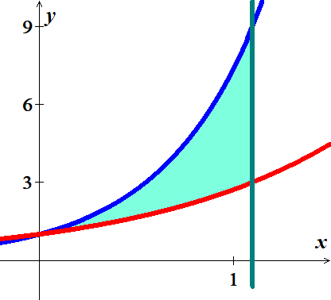











***Exercise***

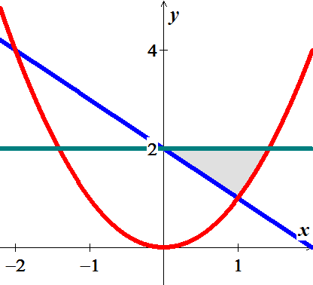Find the area of the triangular region bounded on the left by , on the right by , and above by 

***Solution***









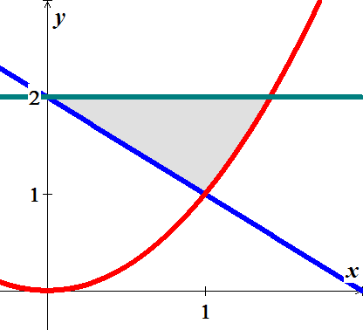











***Exercise***

Find the extreme values of  and find the area of the region enclosed by the graph of *f* and the *x*-axis.

***Solution***

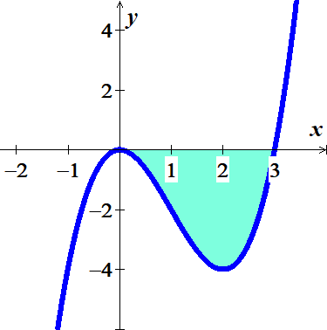







 has a relative minimum at 

 has a relative maximum at 











***Exercise***

Determine the area of the shaded region in

***Solution***

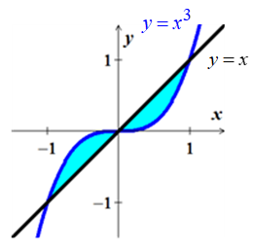













***Exercise***

Determine the area of the shaded region in

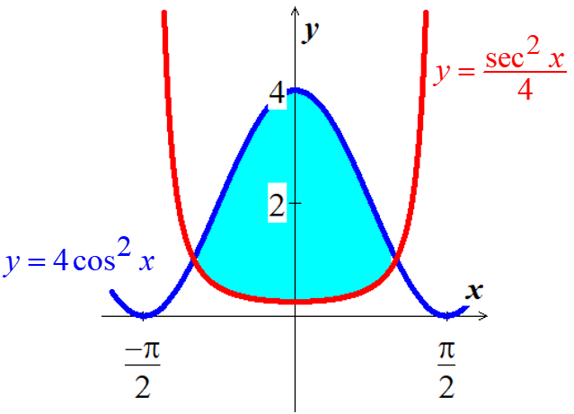

***Solution***









By the symmetry;











***Exercise***

Determine the area of the shaded region in

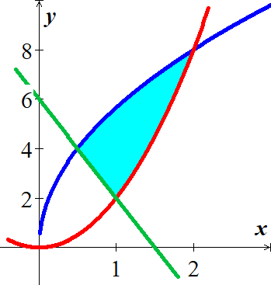

***Solution***







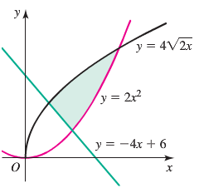





 















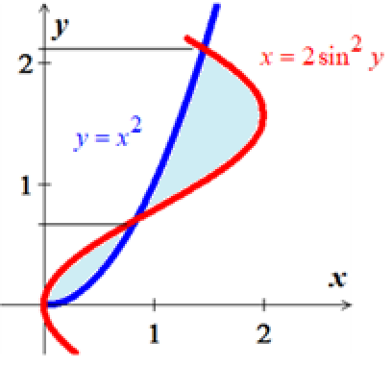***Exercise***

Determine the area of the shaded region in

***Solution***

From the graph the intersection are:













***Exercise***

Determine the area of the shaded regions between 

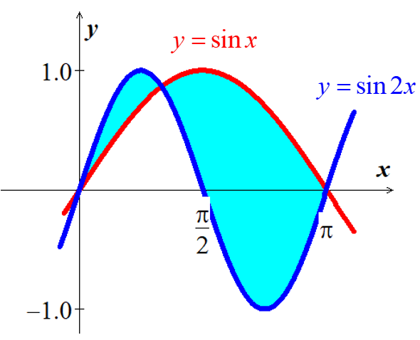***Solution***

















***Exercise***

Determine the area of the shaded region bounded by the curve 

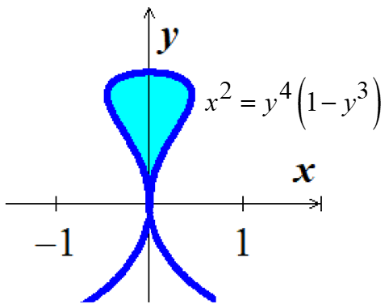***Solution***





Since it is symmetric about *y-*axis, then









***Exercise***

Determine the area of the region bounded by the curves

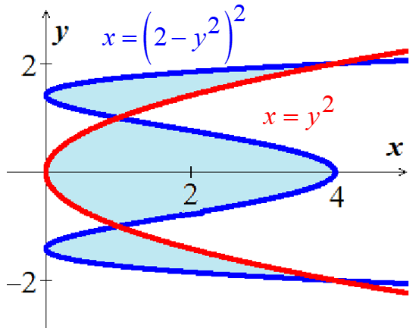 and 

***Solution***





















***Exercise***

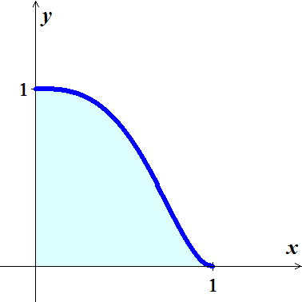Find the area of the region bounded by the curves and line



***Solution***













***Exercise***

Determine the area of the shaded regions:

***Solution***

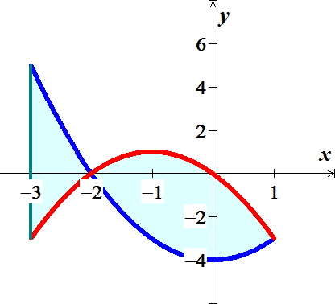













***Exercise***

Determine the area of the shaded regions: 

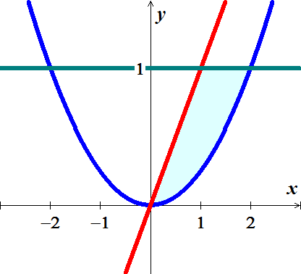***Solution***











***Exercise***

Determine the area of the shaded regions: 

***Solution***



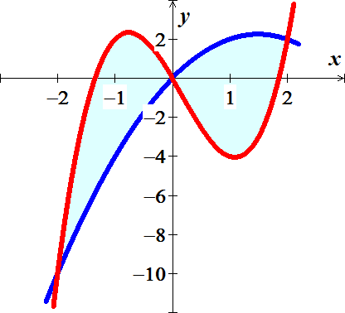









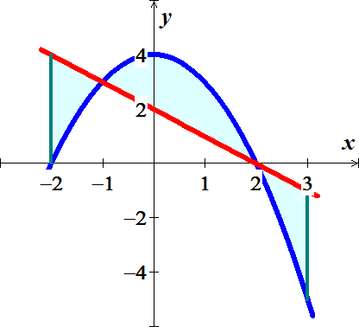***Exercise***

Determine the area of the shaded regions:



***Solution***





















***Exercise***

Determine the area of the shaded regions: 

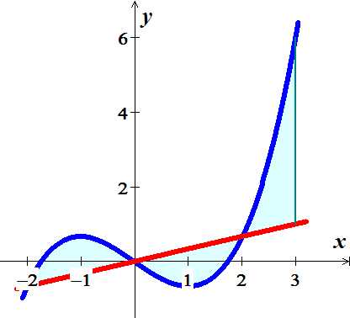***Solution***























***Exercise***

Determine the area of the shaded regions: 

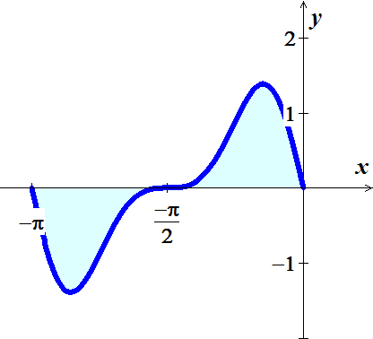

***Solution***













***Exercise***

Determine the area of the shaded regions: 

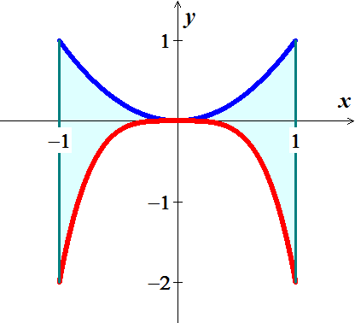***Solution***











***Exercise***

Determine the area of the shaded regions: 

***Solution***

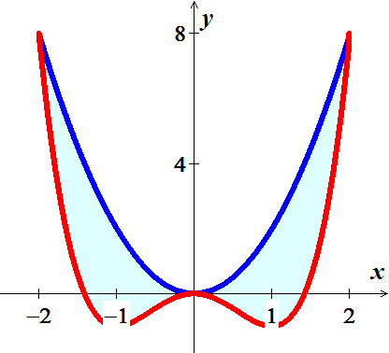











***Exercise***

Find the area between the graph of  and the line segment joining the points  and .

***Solution***

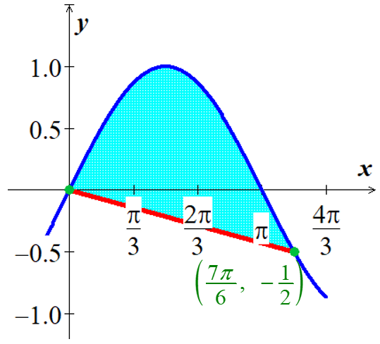***Line***: 











***Exercise***

The surface of a machine part is the region between the graphs of  and 

1. Find *k* where the parabola is tangent to the graph of 
2. Find the area of the surface of the machine part.

***Solution***

1. 





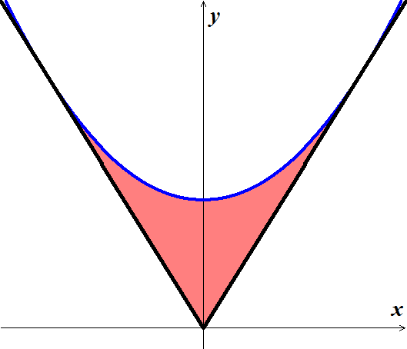







1. 







***Exercise***

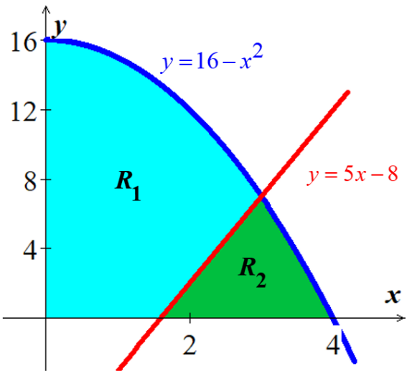Find the area of the regions  and  (separately) shown in the figure, which are formed by the graphs of  and 

***Solution***







Region :



 



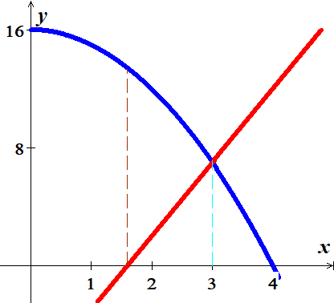 

Region :









***Exercise***

Find the area of the regions ,  and  (separately) shown in the figure, which are formed by the graphs of , , and 

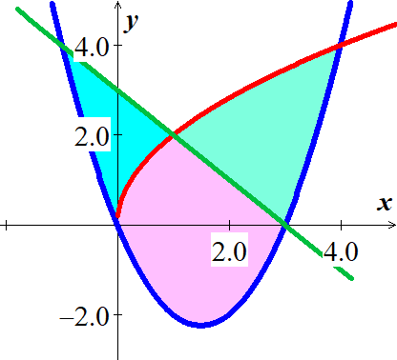***Solution***















Region :









Region :









Region :









***Exercise***

Concrete sections for a new building have the dimensions (in meters) and shape shown in figure

1. Find the area of the face of the section superimposed on the rectangularcoordinate system.
2. Find the volume of concrete in one of the sections by multiplying the area in part (*a*) by 2 *meters*.
3. One cubic meter of concrete weighs 5,000 *pounds*. Find the weight of the section.

***Solution***

1. 

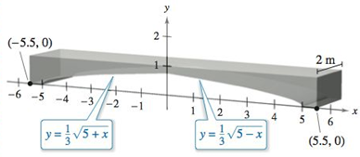 







1. 



1. 



***Exercise***

A Lorenz curve is given by , where  represents the lowest fraction of the population of a society in terms of wealth and  represents the fraction of the total wealth that is owned by that fraction of the society. For example, the Lorenz curve in the figure shows that , which means that the lowest 0.5 (50%) of the society owns 0.2 (20%) of the wealth.

1. A Lorenz curve  is accompanied by the line , called the ***line of perfect equality***. Explain why this line is given the name.
2. Explain why a Lorenz curve satisfies the conditions 
3. Graph the Lorenz curves  corresponding to *p* = 1.1, 1.5, 2, 3, 4. Which value of *p* corresponds to the ***most*** equitable distribution of wealth (closest to the line of perfect equality)? Which value of *p* corresponds to the ***least*** equitable distribution of wealth? Explain.
4. The information in the Lorenz curve is often summarized in a single measure called the ***Gini index***, which is defined as follows. Let *A* be the area of the region between  and  and Let *B* be the area of the region between  and the *x-*axis. Then the Gini index is .

Show that .

1. Compute the Gini index for the cases  and *p* = 1.1, 1.5, 2, 3, 4.
2. What is the smallest interval [*a, b*] on which values of the Gini index lie, for  with ? Which endpoints of [*a, b*] correspond to the least and most equitable distribution of wealth?
3. Consider the Lorenz curve described by . Show that it satisfies the conditions. Find the Gini index for this function.

***Solution***

1. Let the point  on the curve  would represent the notion that the lowest *p*% of the society owns *p*% of the wealth, which would represent a form of equality.
2. The function must be increasing and concave up because the poorest *p*% cannot own more than *p*% of the wealth.
3. 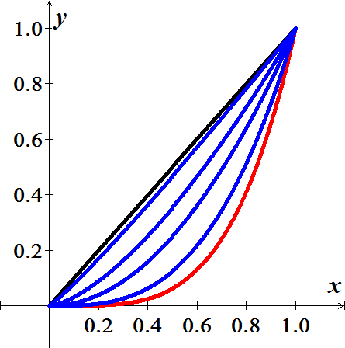 is closet to , and  is furthest from 
4. Since,  and 

Then 







 ***√***

|  |  |  |  |  |  |  |  |  |  |  |  |  |  |
| --- | --- | --- | --- | --- | --- | --- | --- | --- | --- | --- | --- | --- | --- |
| 1. For | |  |  |  |  |  |  | | --- | --- | --- | --- | --- | --- | | ***P*** | 1.1 | 1.5 | 2 | 3 | 4 | | ***G*** |  |  |  |  |  | |

1. For 





, the largest value of *G* approaches 1.

1.  



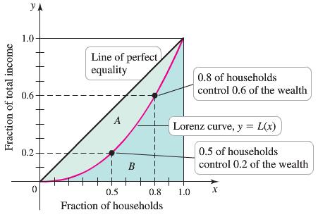

The Gini index is:









